EDINBURGH AND LOTHIANS REGIONAL EQUALITY COUNCIL (ELREC)

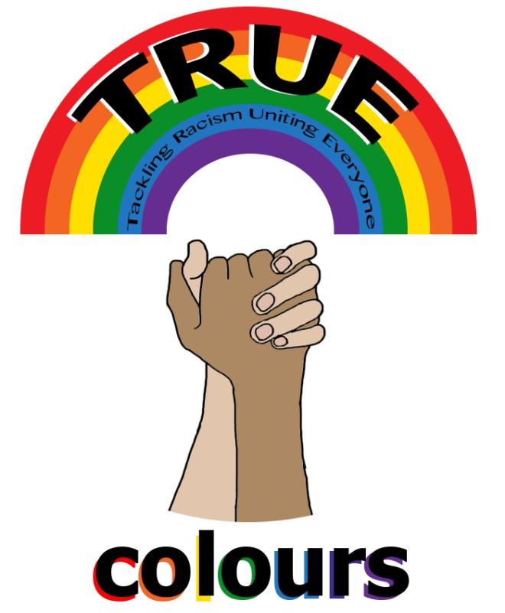True Colours

ANTI-BULLYING TOOLKIT

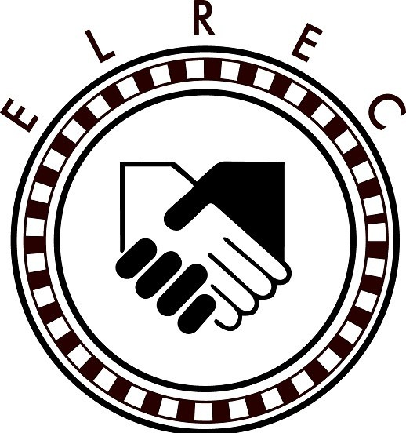
This toolkit is designed to help young people, teachers and youth workers to tackle and challenge bullying

#Equality #Empathy #Compassion

Table of content
Intro on True Colours 1
Services 2
Peer Education Programme 3
What is bullying 5
Cyberbullying 6
How to keep safe online 9
Manners of a digital citizen 10
Why bullying 11
Impact of bullying 13
Equality act 2010 14
Children's Rights 15
Dealing with bullying 16
Strategies and activities 17
Useful games 22
Anti-bullying practice 24
Useful resources

Introduction

TRUE Colours is a youth project focused on raising awareness about different equality issues and prejudice-based bullying in
Edinburgh schools.

Our Aims:

-Empower and encourage young people to challenge bullying
-Promote tolerance and good relations within schools and communities.

-Enable young people to make their voices
heard through peer education programme and

activities.

1

Our service includes two main parts:

- Workshops; this can be at schools or any community place, it is also provided to
organisations to raise awareness opf issues
of equality.

- Peer education/ Ambassadors Programme

- Workshops

Topics covered so far:
-Racism and discrimination
-Islamophobia
-Immigration and Refugees
-LGBT awareness and homo/bi/transphobia
-Cultural awareness
-Gender equality and representation in the Media
-Bullying and Cyberbullying
-Equality Act 2010
-Stereotypes and prejudice
-Disability
-Hate Crime

2

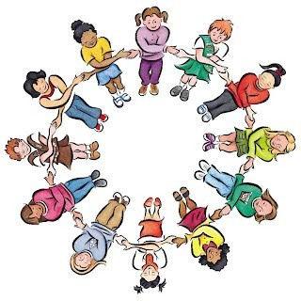

- Peer education programme

The Ambassadors Project is a way in which you can remind people in your school and community
that there is no place for inequality!

-You will campaign for equality for all.
-You can create a team and you all can work on challenging any bullying behaviour.

You will encourage your peers to speak in a
familiar and comfortable environment about the problems of inequality and bullying in their own community.

3

How it works?
Become a Peer Educator

Form a group in your school or work individually

Promote euality and respect for all

Make your own project

Get support from True Colours

Get your voice heard
Make positive change in your school & community

4

What is bullying?

Bullying is:
when an individual or a group
deliberately try to make an individual feel scared, upset or ashamed of who they are.

Types:

-Physical: includes any form of physical harm

-Verbal: this includes teasing, putting down, name calling or using any threatening language

-Emotional: any behaviour that undermines or controls someone, also being left out or excluded.
-Cyberbullying: sending or posting abusive
messages or images.

5

Cyberbullying
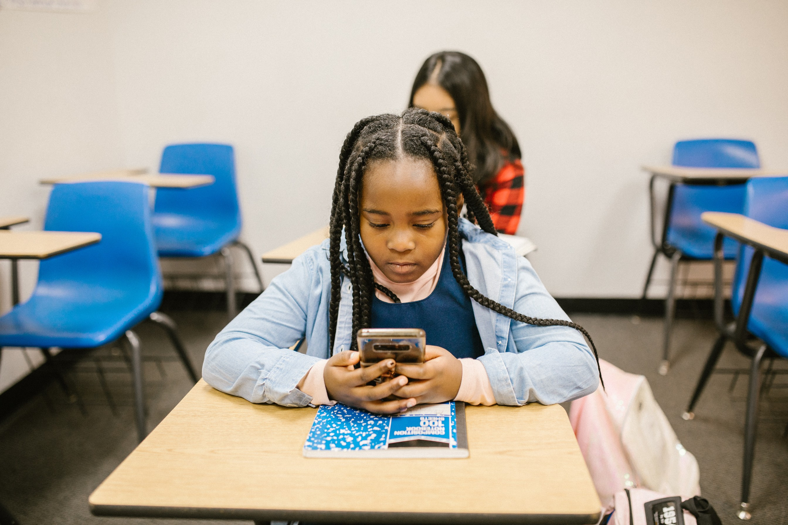
Unlike normal bullying cyberbullying does not happen face-to-face, it happens online when mobile phones or other devices are used to send images or text intended to hurt or embarrass another person.
%59 of young people in Scotland had witnessed increase in cyberbullying during lock-down

6

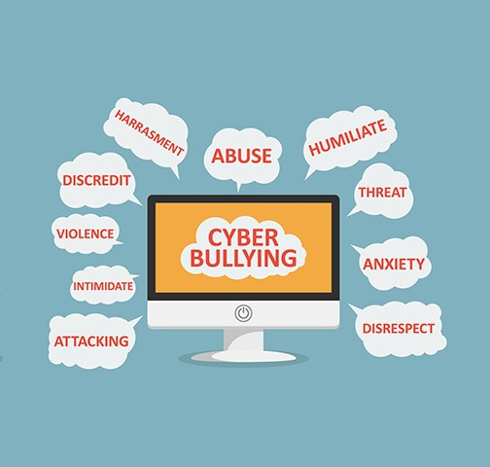Cyberbullying involves...

7

Concequences

-Banned from using school computers

-Expelled from school

-Can be traced by IP or phone company

-Legal action from the victim

-Criminal record

8

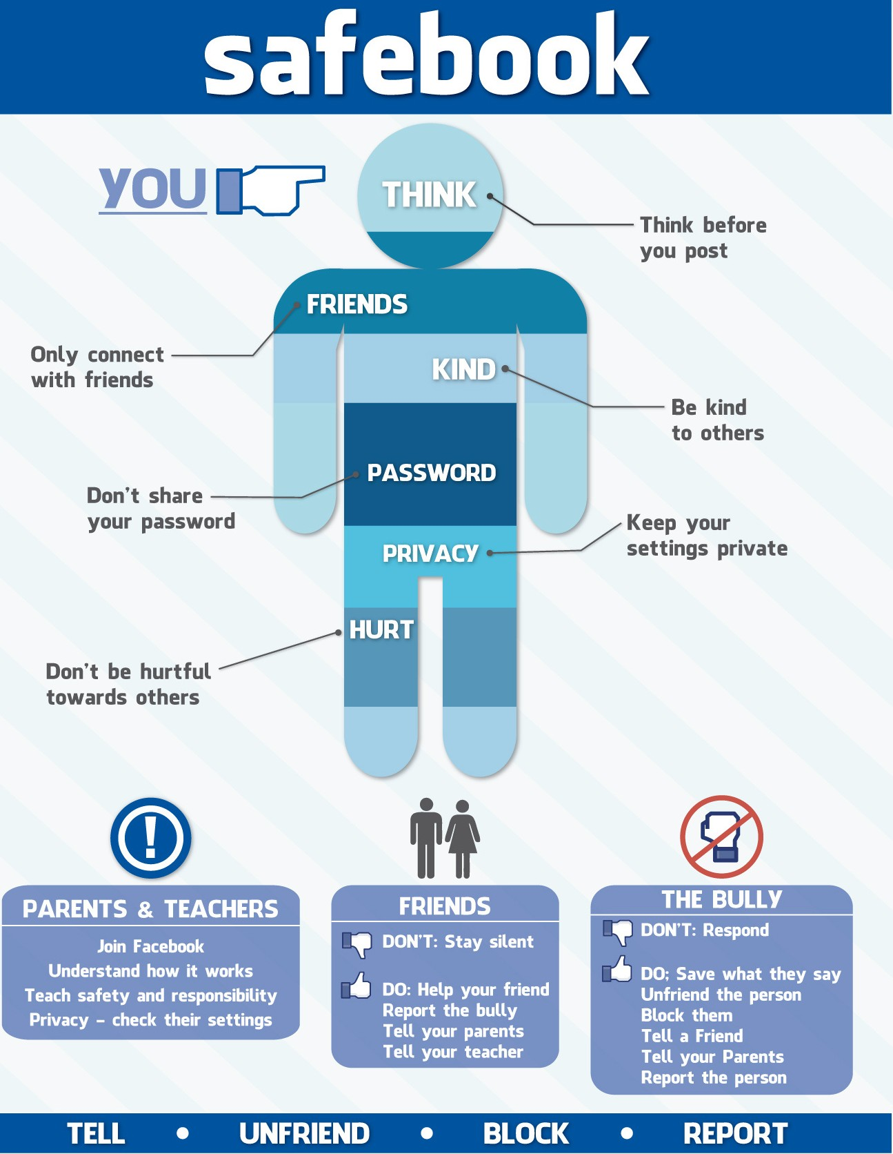Ways to keep safe on Social Media

9

Manners of a digital citizen

I T H I N K
I stop and think before I post, I ask myself: will life other up or put them down? I only post what life other’s up.

I ’ M R E S P E C T F U L
I respect myself and others. I challenge and stand up to any bullying post when I see it.

I ’ M R E S P O N S I B L E
I give credit to those who create new useful media content. I am mindful of what I say on social media and how it can affect others.

I C R E A T E
I use online tools to express my thoughts as long as it doesn’t cause any harm to anyone else or put them down.

I ’ M S A F E
I protect myself and others through protecting my information and the information of others.

10

Why bullying?

-Lack of kind role models

-To gain control and power

-A way to prevent further experience of bullyin

-Not being aware of the impact of bullying

-A lack of perception of their behaviour and consequences

-Lack of respect to other people's difference, whether in appearance, behaviour, race, culture religion, sexual orientation or ability.

11

Why bullying?

Jealousy Insecurity

Powerlessness

Stereotypes

Bullying Attention seeking

Previous experience
Emotional instability

Environmental influences

12

I M P A C T

S O M E F A C T S

New figures were released on bullying in Edinburgh schools state that 344 incidents were reported and racially motivated.
Anxiety and depression Changes in mood and behaviour
Loss of appetite
Upset using computers, phones etc.
Isolation from friends and
school work Grades in class slip
Starts drinking alcohol or
taking drugs Suicidal thoughts

A total of 1348 of bullying incidents were recorded between August 2020-
April 2021

13

Why important to tackle bullying?
Bullying is a violation of children's rights

EQUALITY ACT 2010

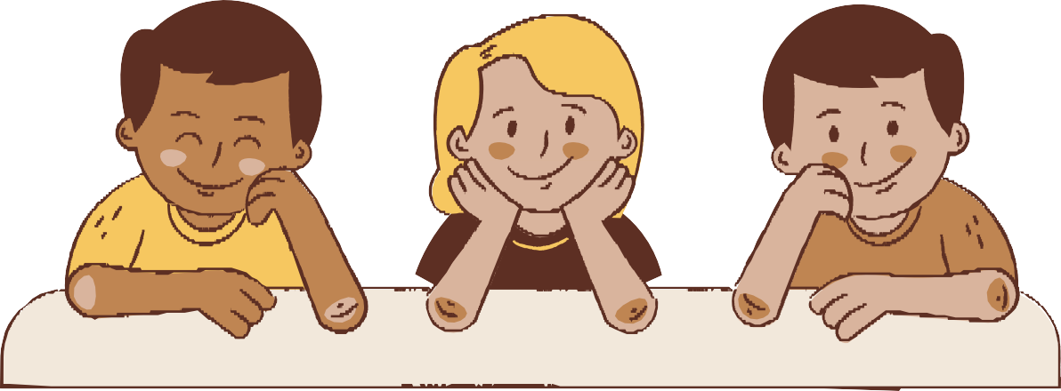
protects children, young people and adults against
discrimination in the
workplace and wider society. It is against the law to
discriminate against
anyone because of their:
Age, being a
transgender person, disability, race
(colour, nationality, ethnic or national
origin) religion or lack of
religion/belief, sex, sexual orientation
(LGB+), being married
or in a civil
partnership and
being pregnant or on maternity leave.

14

Children's Rights
-It’s every child’s right not to be bullied. Children’s rights are unique in that many of
them, although designed for
the safety and protection of children, have to be
provided for by adults and
the government.
-Children and young
peoples’ rights are covered
under the Human Rights Act 1998 and the UN Convention on the Rights of the Child
(UNCRC).
-Although neither
specifically mentions
bullying, bullying behaviour does breach a number of the articles in both –
development, protection and
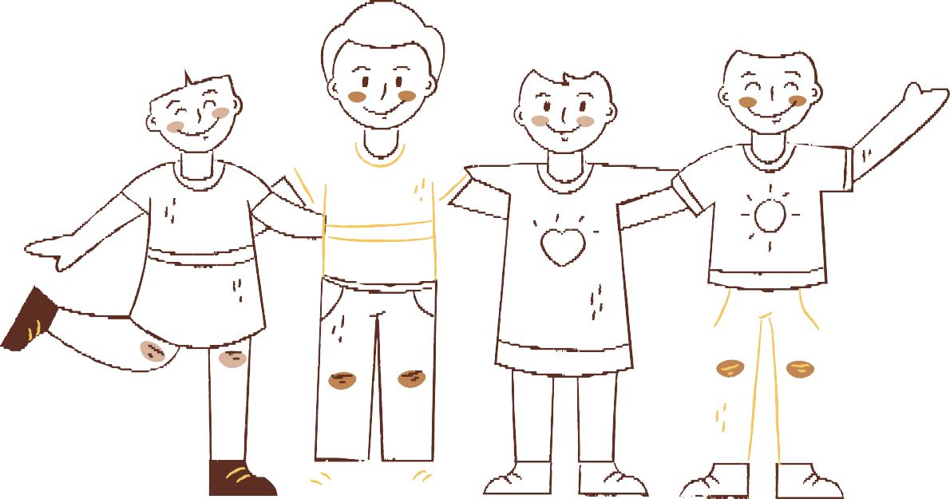participation right, and the right to be respected
without discrimination.

15

Dealing with Bullying
Schools can challenge bullying through building a culture promoting empathy, through three main steps:
- . PREPARE

THIS IS THROUGH CREATING A SAFE SPACE FOR YOUNG PEOPLE FROM
DIFFERENT CULTURES, BACKGROUNDS ETC TO DISCUSS ISSUES
ALSO, CREATING EMOTIONAL
COMPETENCY ENVIRONEMENT WHERE CHILDREN AND YOUNG PEOPLE CAN
PRACTICE FOUR KEY SKILLS WHEN THEY FACE ANY BULLYING
BEHAVIOUR; STOP, BREATHE, LISTEN AND RESPOND SBLR
LASTLY A LEARNING EXAMPLE AT THE SCHOOL WHICH WILL HELP IN
INSPIRING AND INFLUENCING THE
YOUNG PEOPLE PUTTING VALUES OF RESPECT AND EQUALITY INTO
PRACTICE.

- . ENGAGE THIS CAN BE THROUGH
ENGAGING THE CHILDREN AND
YOUNG PEOPLE IN GROUP PLAY,
STORYTELLING
AND COLLECTIVE PROBLEM-
SOLVING
ACTIVITIES.

- . REFLECT AND ACT
REFLECTION HELPS THE CHILDREN AND YOUNG PEOPLE IDENTIFY
SHARED VALUES AND DIFFERENCES THEY HAVE, AND CREATES AN
ENVIRONMENT BASED ON
UNDERSTANDING, RESPECT AND KINDNESS.

16

Strategies and activities to challenge bullying

Face it with confidence
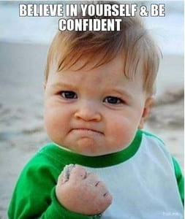
Bullies are less likely to target you if you show a calm, respectful and confident attitude. Have awareness of things happening around you, this will help you notice problems when they first happen, this will make you act before things get more difficult to deal with.

Accept who you are:
Through being able to recognize your value as a person. It is essentially your level of self- worth and feeling of comfort in your own skin regardless of your shortcomings and weaknesses. With self-acceptance you reach
your full potential. 17

This video is a great example o this #itsnotaboutme
USEFUL VIDEO
https://youtu.be/r_nYzMgSMc0

How to put this in practice?

Activity
You can do this in a class setting, do a confidence walk game! Sit or stand heads up and shoulders
straight.
Give the young people feedback and praise when they get it perfect. You can say things like ‘have eye contact/ look around’, ‘head up high’, ‘that’s it, great’. All this will give them a real-life experience on how to always be this way.

18

Use your voice
Most the bullies don’t want to get caught; despite they are being hurtful in purpose. A great tool to teach the students is to use their voice.

Activity:
Coach and encourage them to pull away and yell ‘No!’, Stop! Go away! Help!’ Practice together; to stand up tall and look at the person in the eye and speak in a firm tone with their hands up as a barrier between them and the bully.

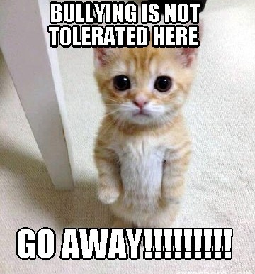
19

Talking to an adult

This can be the best advice, however, some young people would worry of being judged as being a grass or of adults ‘over-reaction’. Be sure that telling the right adult, someone who you really trust whether it is your parent, teacher, coach or older sibling etc. as long as you trust them, they will listen to you and to how you want this to be resolved and keep you updated if they took any action.

Talking to a friend
Don’t keep it to yourself. If you find it difficult to talk to an adult, then a close friend who you trust can be easier to start with. A trustworthy friend will be able to listen to you and can also help you to seek support and advice by accompanying you when going to speak to them. This will help in letting it out, so it’s not bottled up and causing you over-thinking or distress and you will feel better after.

20

Leave in a Heads-up Positive Way

This tool can be used of the child or young person is in a situation being bullied. It can be the best self-defence which is ‘target-denial’. As bullies often show such behaviours for attention, so when they don’t get that, they stop doing it.

#How to put this in practice:
Activity:
You can act as you are a bully and shouting negative words, then get each one in class to walk in a confident, positive way when completely ignoring you ‘the bully’. This will be empowering to them and will teach them to always act with pride of who they are, without giving the power to anyone else to control their feelings.

21

Useful games

Human Bingo

A good game to help young people find things in common & learn about their differences in a fun way

Ask around to fill all the spaces – you may only use a person’s name once
Find someone who:
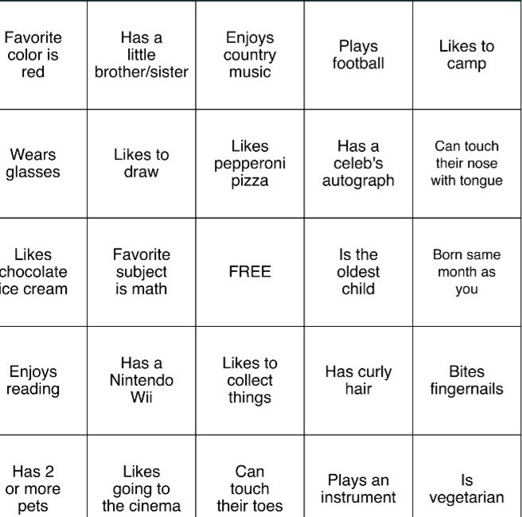
22

“Bursting stereotypes” Game

This is a fun way to get young people challenge stereotypes that can cause bullying

Have balloons with some harmful and non-harmful stereotypes written on them in black marker.

Then have a couple of balloons that have true statements about race on.
Have enough balloons so that each student can ‘burst’ at least one stereotype
Harmful stereotypes: All Americans are obese
Immigrants are only here for the benefits All Muslims are terrorists

Unharmful stereotypes: All Scottish people eat haggis
English people love tea

They are all stereotypes, even though some seem less harmful or prejudicial, it is still not good to make sweeping statements over a whole population.

23

-This should be established in all schools and organisations where a culture on respect, kindness, compassion is encouraged.

ANTI-BULLYING PRACTICE

Difference is celebrated and positive friendships are encouraged. All this will make it difficult for any bullying behaviour to find a way in and if it did happen, it will never be tolerated or get a chance to thrive.

How to put this in practice :
-Secure relationships and friendships

-Good adult role models who set safe boundaries and give guidance when needed.

-Giving children and young people constant love, compassion, praise and recognition which will help in building their confidence and self-esteem.

-Promoting optimism, active listening and hobby building.

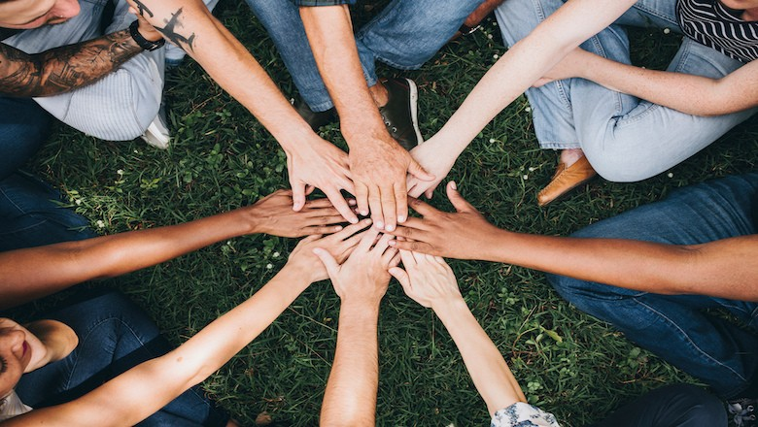
love, peace, and joy

24

Useful Resources

-Respect me: is a service in Scotland that supports children, young people and adults through tips and advice on how to deal with bullying in the best way. Find out more@ https://respectme.org.uk/

-CThildren’s line: is a safe helpline to support families who have children and young people who are facing bullying. Find out more @ https://www.childline.org.uk/

-Bullying UK https://www.bullying.co.uk/ The charity Bullying UK runs a website that has lots of information and advice on bullying, including Cyberbullying.

-TThe Anti-Bullying Network www.antibullying.net

- City of EdinburgTh Council, you can find out about different bullying policies in the City of Edinburgh Council website @ https://www.edinburgh.gov.uk/schools- learning/bullying-harassment/1

25

-
Edinburghlivehttps://www.edinburghlive.co.uk/ne ws/edinburgh-news/edinburgh-school-pupils- reporting-incidents-20650495

-Mentally healthy schools, https://www.mentallyhealthyschools.org.uk/ a good website to go through with some materials,
videqas presentations that teachers and students can relate to.

-Children 1st https://www.children1st.org.uk/help- for-families/parentline-scotland/guidance- advice/bullying/

-National Bullying helpline https://www.nationalbullyinghelpline.co.uk/about.h tml

For more resources, workshops and games, please find us online@ https://www.elrecl.org.uk/true-colours/

26

Edinburgh & Lothians Regional Equality Council 14 Forth Street, Edinburgh EH1 3LH
T. 0131 556 0441
2021
